DRAFT
Examples of Increasing Difficulty Questions for NIQB Quantitative Competencies
Please review and let the Math Team know
- If such examples would be a useful resource
- If they would be a useful resource, should/how should the content be modified to make it most useful
- What formatting would be make the document most user friendly

Preface:
The “difficulty” of a problem can be increased in multiple ways. For example, the difficulty of a question can be increased by
- Asking about a topic further along curriculum
and/or
- Increasing the level of complexity and/or cognitive demand and/or level of reasoning
These two ways to increase difficulty are not mutually exclusive and are not an exhaustive list of ways to increase problem difficulty
- Asking about a topic further along the curriculum
Multiplication is a topic that usually follows addition
- Increasing the level of complexity and/or cognitive demand and/or level of reasoning.
Asking students to explain why the following pair of addition problems are similar is more difficult than asking them to do the calculation for each.

What do these problems have in common?
57 + 68 =
50 + 60 + 15 =

The following graphic illustrates the non-exclusive distinction between cognitive demand and curricular progression. As module development teams consider the problem types they could develop for student learning assessment and for module activities, they may want to consider developing a balanced range of problem types in terms of cognitive demand.

The Math Team has used three designations of difficulty, Low Difficulty, Medium Difficulty, and High Difficulty to label problem difficulty levels

Example: Comparing Ratios

Low Difficulty – Simple comparison
Which is greater 2/3 or 4/5?

Medium Difficulty - More complex comparison and requires interpretation. This problem is more complex because it involves interpreting a written description to develop a mathematical representation. The ratios are purposely misleading.
- Mr. Brown is a bicycle rider. He considered bicycling in three towns. His goal is to bicycle in a town where there is the lowest density of cars. Which town would best meet his goal? (From Teaching Fractions and Ratios for Understanding Essential Content Knowledge, Susan J Lamon)
- 15 sq miles 12,555 cars
- 3 sq miles, 2502 cars
- 17 sq miles; 14, 212 cars
- Which is more “square”, a rectangle that measures 35 x 39 or one that measures 22 x 25? ( From Teaching Fractions and Ratios for Understanding Essential Content Knowledge, Susan J Lamon)

High Difficulty - More complex comparison and interpretation as well as explanation and application. This problem is even more complex because it involves determining the ratios from the given written information, comparing ratios and then using that information to determine surface area. Because it requires explaining one’s work it also requires deeper understanding (See Appendix 1 Bloom’s taxonomy)).
- The surface area of Earth is 5.1 x 108 square km, and 71% of Earth’s surface is covered in water. The diameter of the moon is 3475 km, and there is no water on the surface of the moon. Which has more dry land, Earth or the moon? Show and/ or explain the work necessary to support your answer. (From Achieve 2019 A Framework to Evaluate Cognitive Complexity in Mathematics Assessments)

On the following pages we provide some examples of problems of increasing difficulty for some of the NIQB quantitative competencies. These examples do not cover all the competencies nor all the subcategories for each competency. The Math Team will be able to provide additional examples through the module development process. We do not consider these examples as the definitive examples of each competency. We welcome feedback on the content and format. The Math Teams hope these examples will be helpful as module development teams design module questions and student learning assessment questions.

- Quantitative Competency 1. Demonstrate quantitative numeracy and facility with the language of mathematics [SFFP1]
- Explain dimensional differences using numerical relationships, such as ratios and proportions
- Use dimensional analysis and unit conversions to compare results expressed in different systems of units
- Low Difficulty: One unit/dimension; convert one unit/dimension - Convert 6 minutes to the equivalent in hours
- Low Difficulty: Two dimensions but only convert one of the units/dimensions:
  - Convert 6 ml/minute to the equivalent in ml/hour
  - Convert 6 ml/minute to the equivalent in ml/day (One dimension but more steps)
- Medium Difficulty: Convert two units/dimensions
  - Convert 6 ml/minute to the equivalent in liters/hour
  - Convert 6 mm/minute to the equivalent in km/day (More steps for both dimensions)
- High Difficulty: Convert two units/dimensions that are more complex dimensions and/or interpret a more complex situation before determining conversions.
  - Metric to US units - Convert a density of 13.6 g/mL to its equivalent in lb/ft³ (http://www2.ucdsb.on.ca/tiss/stretton/Basic_skills/Dimensional_Analysis_Contents.htm)
  - How many m³ are in 3 cm³ ? (Answer 3 x 10⁻⁶)
  - A mole of hydrogen atoms contains 6.02 X 10²³ atoms and occupies 22.4 L. Convert to the number of hydrogen atoms in one liter, assuming same density. http://www2.ucdsb.on.ca/tiss/stretton/Basic_skills/Dimensional_Analysis_Contents.htm

Competency #2: Interpret data sets and communicate those interpretations using visual and other appropriate tools.
- Interpret appropriate graphical representations of data, using (but not limited to): frequency histogram, scatter plot, bar graph, box and whisker, semi-log graphs, double reciprocal graph, pie chart
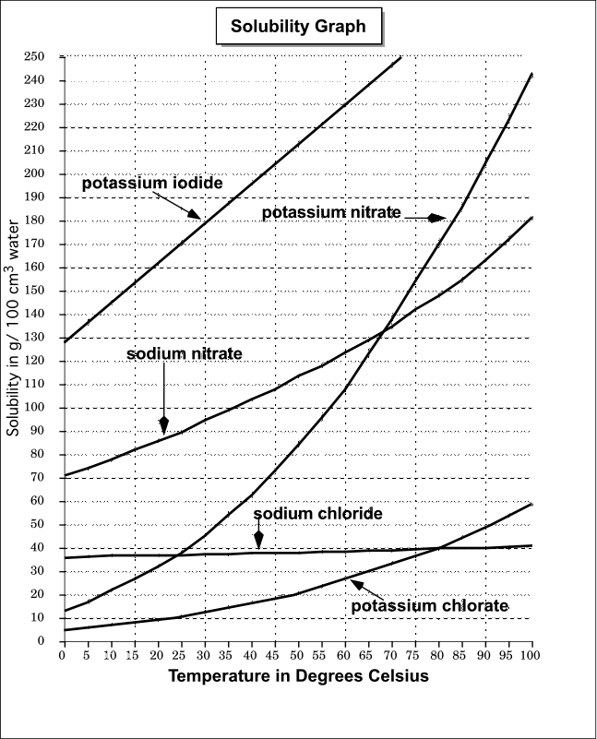
Low Difficulty: Simple Interpretation.
Based on the graph, which compound is the least soluble at 55 degrees C?

Medium Difficulty: Slightly more complex interpretation. Based on the graph, list all the pairs of compounds have equal solubility at specific temperatures and the temperatures at which equality occurs.

High Difficulty: More in-depth interpretation and an explanation required.
Based on the graph, for which compound does the solubility increase the most between 0 and 30 degrees C? For which compound does the solubility increase the most between 0 and 100 degrees C? Explain your answer for each. Compare the graphs.

Competency #3: Demonstrate proficiency with statistical analyses and make inferences [SFFP3]

- Compute and interpret descriptive quantitative statistics, such as mean, standard deviation, standard error, confidence intervals, and variance
  - Low Difficulty – compute statistics using technology, or on small data sets (mean, std. dev., variance, standard error); compare given statistics from different data sets
  - Medium Difficulty – compute statistics by hand, using the formulas or on larger data sets; interpret statistics already computed
  - High Difficulty – Determining which analyses to use; compute and interpret a variety of statistics including confidence intervals
- Apply statistical analyses to biological data sets (e.g., Chi-square and t-Test) and interpret findings
  - Low Difficulty – compute Chi-square by hand for individual cases; determine if conditions are met for testing; compute t-scores by hand or with technology
  - Medium Difficulty – compute test statistics; interpret test findings;
  - High Difficulty – write null and alternative hypotheses; interpret results and make conclusions to hypothesis tests;
  - Example: You think that people’s ice cream favorites are reflected by the following model: 25% vanilla, 25% chocolate, 20% strawberry, 15% butter pecan, 8% rocky road, 7% other or no preference. You survey 1000 people and find the following preferences: 220 vanilla, 255 chocolate, 190 strawberry, 170 butter pecan, 95 rocky road, 70 other/no preference. Using alpha = 0.05, was your idea right or wrong?
    - Low Difficulty: Compute the chi-square value for both vanilla and chocolate ice cream (by hand)
    - Low Difficulty: Are the appropriate conditions met in order to run a chi-square test?
    - Low Difficulty: How many people would your model predict chose “butter pecan” as their favorite ice cream?
    - Medium Difficulty: Compute the test statistic (chi-square) for this test, assuming the null hypothesis says your model fits data, and the alternative says that the model does not fit the data collected.
    - Medium Difficulty: If $χ^{2}=9.679$, and the $p-value=0.085$, would you reject the null hypothesis or fail to reject it?
    - Medium Difficulty: What are the degrees of freedom for this chi-square test? How is this significant?
    - High Difficulty: If $χ^{2}=9.679$, and the $p-value=0.085$, what is the appropriate conclusion to this test in the context of the problem?
    - High Difficulty: What would be an appropriate null and alternative hypothesis for this test?
    - High Difficulty: How might these results change if we were to sample a larger group? Smaller group?
- Calculate frequencies and probabilities of biological phenomena
  - Low Difficulty – define probability & frequency; calculate probabilities
  - Medium Difficulty – calculate frequencies & relative frequencies; interpret visual representations (histograms, probability diagrams); utilize the addition rule
  - High Difficulty – compute probabilities and frequencies using real life data; interpret probabilities and frequencies in context; interpret results from use of probability formulas
- Predict the effect of sample size on experimental outcomes
  - Low Difficulty – compare small and large sample sizes to their experimental outcomes
  - Medium Difficulty – draw conclusions about sample sizes and experimental outcomes
  - High Difficulty – make predictions about outcomes based on sample sizes provided

Competency #4: Demonstrate facility with mathematical models of biological systems and be able to make inferences about natural phenomena [SFFP 5]

- Identify and compare linear and non-linear relationships between biological quantities
  - Example: Let the number of algae be denoted by A, with a birth rate of b and a death rate of d. Similarly, let a population of bacteria be modeled by B(t)=B₀e^{rt}, where B₀ denotes the population at time 0 and r is the net growth rate of the population.
  - Low Difficulty: Evaluate values using linear and nonlinear biological modeling equations
    - If the birth rate is b=4, the death rate is d=2, and the initial population is 100, then A(t)=2t+100. How many algae are there at time t=0? How many algae are there at time t=1? At time t=2? Graph A(t).
    - If r=3/2 and there is an initial population of bacterial of B₀=25, when are there 100 bacteria? What is the population when t=4? Graph B(t).
  - Medium Difficulty: Compare and contrast model predictions for linear and nonlinear models: If both algae and bacterial start off at t=0 with the same number of 100, then A(t)=2t+100 and B(t)=100e^{3/2 t}. What is the size of both populations at time t=10? Which population is bigger? Why?
  - High Difficulty: Select the correct model, linear and/or a nonlinear model, and create the equation: Example: Assume that a population of insects have a constant birth and death rate and that those rates are the only elements that impact the insect population. Would you model this with a linear model or a nonlinear model ? Why?

- Identify the relationship between the dependent and independent variables in a model
  - Low Difficulty: Recognize the dependent and independent variables in a given model
    - The previous model of algae and bacteria growth predicted the size of the population at any time t.
    - What is the independent variable? What is the dependent variable? On the graphs above, on which axis did you put the independent variable?
  - Medium Difficulty: Identify dependent and independent variables when creating a model:
Example: If each generation of mice produce 100 mice, how many mice have been produced after 5 generations? What is the independent variable? What is the dependent variable?
  - High Difficulty: Identify dependent and independent variables in inverse functions and also when the independent variable is not time
    - Consider the model of the bacteria population: B(t)=B₀e^{rt}. Solve the equation for t in terms of B. This is called the inverse function. What is the independent variable in the inverse function? What is the dependent variable?
    - In a dosage study, a certain medicine is given to patients at varying dosages in order to identify the optimal dosage that will be sufficient to cure the illness and minimal enough to minimize the side effects.
    - What is the independent variable? What is the dependent variable? Why?
- Predict biological phenomena using mathematical models (e.g., exponential population, Nerst equation, estimating protein concentrations, amplification of signaling pathways, or iterative models)
  - Example: Assume that an initial population of 10 insects produces 100 insect eggs each generation and 50% of them survive.
    - Low Difficulty: Predict future biological quantities using a model:
How many insect eggs survive after 2 generations? After 3 generations?
    - Medium Difficulty: Understand how the model predicts future biological quantities:
Using your answer to the previous question, how many insect eggs have survived after t generations?
How many insects are there after t generations?
    - High Difficulty: Develop biological models and interpret the results in a biological framework: Example: Oxygen goes from the lungs to the bloodstream using a process known as diffusion. Assume that a lung of volume 1 has a concentration of oxygen L and that a blood vessel also of volume 1 has oxygen concentration B, presumably with L>B. Fick’s Law of diffusion is given by ΔB = B_{t+1} – B_{t} = r(L-B) where r is the diffusion constant, ie how efficiently the oxygen moves from the lung to the bloodstream over a small time interval. The notation ΔB denotes the change in oxygen concentration in the blood stream over one time interval. Should ΔB be positive or negative? Why? To properly represent a diffusive process, what range of values should r take on? What does it mean if r=1? (Adapted from Mathematical Models in Biology, An Introduction by Allman and Rhodes, p. 30)

Competency #5: Apply algorithmic approaches and principles of logic (including distinction between cause/effect and association) to problem solving

- Define a scientific hypothesis and design an experimental approach to test its validity
- Low Difficulty: A good hypothesis must contain two parts – what are they? (that it is testable and can be replicated)
- Medium Difficulty: Explain whether “If it snows, then shovel sales increase” is a valid scientific hypothesis.
- High Difficulty: What is the difference between a Type 1 and a Type 2 error?

- Distinguish correlation from causality
- Low Difficulty: What is the difference between correlation and causation?
- Medium Difficulty: Based on observation, ice cream sales go down when hot cocoa sales go up. Is this correlation or causation? Explain your answer.
- High Difficulty: Tyler Vigen has an entire website devoted to “Spurious Correlations” https://www.tylervigen.com/spurious-correlations
Create your own Spurious Correlation.

- Critically evaluate if scientific conclusions from a study are warranted
- Low Difficulty: You ran an experiment to see if people who wear glasses do better on exams and determined that yes, they did. What other factors could play a role in why the students who wore glasses did better?
- Medium Difficulty: In comparing pea plants versus sunflowers, the experiment showed that sunflowers, which were sung to, grew taller than the peas, which were not sung to. Is the conclusion “singing to plants causes them to grow taller” a valid conclusion? Why or why not?
- High Difficulty: In experiments with human subjects, often times the experiment is “double blind” – meaning that neither the researchers nor the subjects know whether they are in the control group. Why do you think this is beneficial?

Appendix 1 Bloom’s Taxonomy
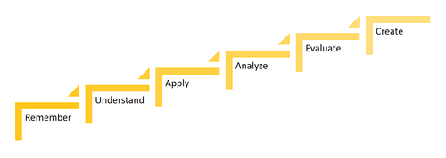
Bloom’s taxonomy provides one framework for increasing difficulty by illustrating what is meant by increasing the level of reasoning required to do a problem.

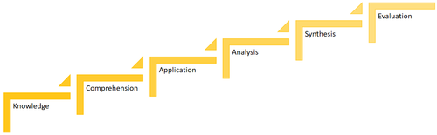
Original Bloom’s taxonomy (1956)
https://uwaterloo.ca/centre-for-teaching-excellence/teaching-resources/teaching-tips/planning-courses-and-assignments/course-design/blooms-taxonomy

Revised Bloom’s taxonomy - Anderson & Krathwohl (2001)

Another visual -
https://cft.vanderbilt.edu/guides-sub-pages/blooms-taxonomy/#:~:text=Familiarly%20known%20as%20Bloom's%20Taxonomy,Analysis%2C%20Synthesis%2C%20and%20Evaluation.

